Link github project

<https://github.com/sugartank555/Lab3>

<https://github.com/sugartank555/Lab3-2>

<https://github.com/sugartank555/Lab4>

1150080012 Bùi Hải Đường CNPM1

* Lab3 + Lab 4

+Lab 3:

Bước 1 : tạo project với tên lab 3

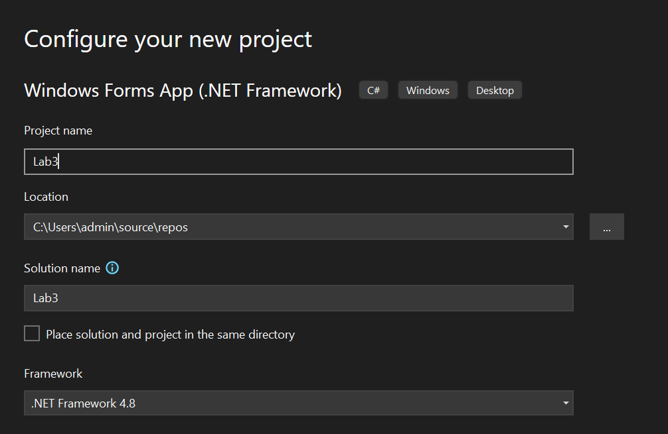

Bước 2: Thiết kế các nút

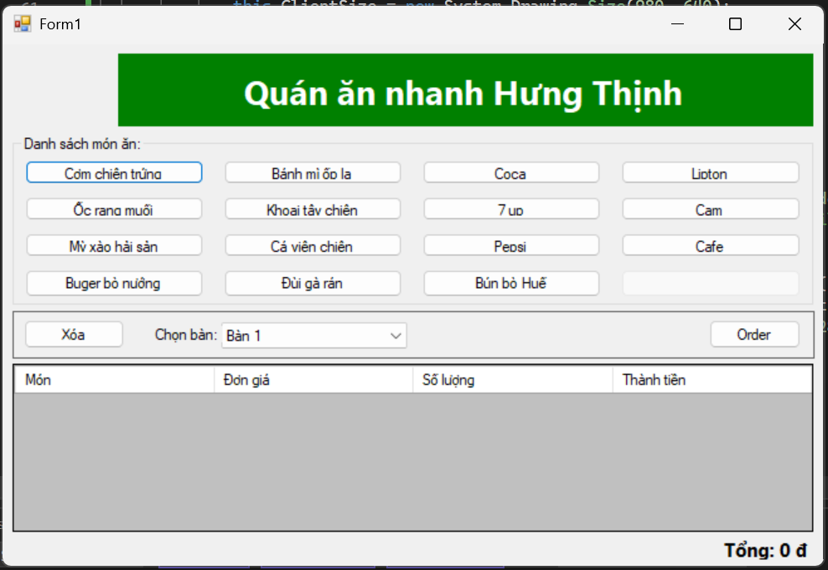

namespace Lab3 { partial class Form1 { private System.ComponentModel.IContainer components = null;

// Controls  
 private System.Windows.Forms.PictureBox picLogo;  
 private System.Windows.Forms.Panel pnlHeader;  
 private System.Windows.Forms.Label lblTitle;  
  
 private System.Windows.Forms.GroupBox gbMenu;  
 private System.Windows.Forms.TableLayoutPanel tblButtons;  
  
 private System.Windows.Forms.Panel pnlToolbar;  
 private System.Windows.Forms.Button btnXoaDong;  
 private System.Windows.Forms.Label lblChonBan;  
 private System.Windows.Forms.ComboBox cboBan;  
 private System.Windows.Forms.Button btnOrder;  
  
 private System.Windows.Forms.DataGridView dgvOrder;  
 private System.Windows.Forms.Label lblTong;  
  
 protected override void Dispose(bool disposing)  
 {  
 if (disposing && (components != null)) components.Dispose();  
 base.Dispose(disposing);  
 }  
  
 #region Windows Form Designer generated code  
 private void InitializeComponent()  
 {  
 this.components = new System.ComponentModel.Container();  
  
 this.picLogo = new System.Windows.Forms.PictureBox();  
 this.pnlHeader = new System.Windows.Forms.Panel();  
 this.lblTitle = new System.Windows.Forms.Label();  
  
 this.gbMenu = new System.Windows.Forms.GroupBox();  
 this.tblButtons = new System.Windows.Forms.TableLayoutPanel();  
  
 this.pnlToolbar = new System.Windows.Forms.Panel();  
 this.btnXoaDong = new System.Windows.Forms.Button();  
 this.lblChonBan = new System.Windows.Forms.Label();  
 this.cboBan = new System.Windows.Forms.ComboBox();  
 this.btnOrder = new System.Windows.Forms.Button();  
  
 this.dgvOrder = new System.Windows.Forms.DataGridView();  
 this.lblTong = new System.Windows.Forms.Label();  
  
 ((System.ComponentModel.ISupportInitialize)(this.picLogo)).BeginInit();  
 this.pnlHeader.SuspendLayout();  
 this.gbMenu.SuspendLayout();  
 ((System.ComponentModel.ISupportInitialize)(this.dgvOrder)).BeginInit();  
 this.pnlToolbar.SuspendLayout();  
 this.SuspendLayout();  
  
 // ===== FORM =====  
 this.AutoScaleDimensions = new System.Drawing.SizeF(9F, 20F);  
 this.AutoScaleMode = System.Windows.Forms.AutoScaleMode.Font;  
 this.ClientSize = new System.Drawing.Size(980, 640);  
 this.MinimumSize = new System.Drawing.Size(900, 600);  
 this.Name = "Form1";  
 this.Text = "Form1";  
  
 // ===== LOGO (trái trên) =====  
 this.picLogo.Location = new System.Drawing.Point(12, 12);  
 this.picLogo.Name = "picLogo";  
 this.picLogo.Size = new System.Drawing.Size(120, 90);  
 this.picLogo.SizeMode = System.Windows.Forms.PictureBoxSizeMode.Zoom;  
 // Bạn có thể gán ảnh ở Form1.cs: picLogo.Image = Image.FromFile(...);  
  
 // ===== HEADER BANNER XANH =====  
 this.pnlHeader.Anchor = ((System.Windows.Forms.AnchorStyles)(((System.Windows.Forms.AnchorStyles.Top | System.Windows.Forms.AnchorStyles.Left)  
 | System.Windows.Forms.AnchorStyles.Right)));  
 this.pnlHeader.BackColor = System.Drawing.Color.FromArgb(0, 128, 0); // xanh đậm  
 this.pnlHeader.Location = new System.Drawing.Point(138, 12);  
 this.pnlHeader.Name = "pnlHeader";  
 this.pnlHeader.Size = new System.Drawing.Size(830, 90);  
 this.pnlHeader.TabIndex = 1;  
  
 // Tiêu đề  
 this.lblTitle.AutoSize = false;  
 this.lblTitle.Dock = System.Windows.Forms.DockStyle.Fill;  
 this.lblTitle.ForeColor = System.Drawing.Color.White;  
 this.lblTitle.Font = new System.Drawing.Font("Segoe UI", 20F, System.Drawing.FontStyle.Bold);  
 this.lblTitle.TextAlign = System.Drawing.ContentAlignment.MiddleCenter;  
 this.lblTitle.Text = "Quán ăn nhanh Hưng Thịnh";  
 this.pnlHeader.Controls.Add(this.lblTitle);  
  
 // ===== GROUPBOX MENU =====  
 this.gbMenu.Anchor = ((System.Windows.Forms.AnchorStyles)(((System.Windows.Forms.AnchorStyles.Top | System.Windows.Forms.AnchorStyles.Left)  
 | System.Windows.Forms.AnchorStyles.Right)));  
 this.gbMenu.Location = new System.Drawing.Point(12, 112);  
 this.gbMenu.Name = "gbMenu";  
 this.gbMenu.Size = new System.Drawing.Size(956, 210);  
 this.gbMenu.Text = "Danh sách món ăn:";  
  
 // Bảng nút 4 cột x 4 hàng  
 this.tblButtons.ColumnCount = 4;  
 this.tblButtons.RowCount = 4;  
 this.tblButtons.Dock = System.Windows.Forms.DockStyle.Fill;  
 this.tblButtons.ColumnStyles.Add(new System.Windows.Forms.ColumnStyle(System.Windows.Forms.SizeType.Percent, 25F));  
 this.tblButtons.ColumnStyles.Add(new System.Windows.Forms.ColumnStyle(System.Windows.Forms.SizeType.Percent, 25F));  
 this.tblButtons.ColumnStyles.Add(new System.Windows.Forms.ColumnStyle(System.Windows.Forms.SizeType.Percent, 25F));  
 this.tblButtons.ColumnStyles.Add(new System.Windows.Forms.ColumnStyle(System.Windows.Forms.SizeType.Percent, 25F));  
 this.tblButtons.RowStyles.Add(new System.Windows.Forms.RowStyle(System.Windows.Forms.SizeType.Percent, 25F));  
 this.tblButtons.RowStyles.Add(new System.Windows.Forms.RowStyle(System.Windows.Forms.SizeType.Percent, 25F));  
 this.tblButtons.RowStyles.Add(new System.Windows.Forms.RowStyle(System.Windows.Forms.SizeType.Percent, 25F));  
 this.tblButtons.RowStyles.Add(new System.Windows.Forms.RowStyle(System.Windows.Forms.SizeType.Percent, 25F));  
  
 // Thêm 16 nút theo thứ tự như ảnh  
 string[,] labels = new string[4, 4] {  
 { "Cơm chiên trứng", "Bánh mì ốp la", "Coca", "Lipton" },  
 { "Ốc rang muối", "Khoai tây chiên", "7 up", "Cam" },  
 { "Mỳ xào hải sản", "Cá viên chiên", "Pepsi", "Cafe" },  
 { "Buger bò nướng", "Đùi gà rán", "Bún bò Huế", "" }  
 };  
  
 for (int r = 0; r < 4; r++)  
 {  
 for (int c = 0; c < 4; c++)  
 {  
 var text = labels[r, c];  
 var btn = new System.Windows.Forms.Button();  
 btn.Dock = System.Windows.Forms.DockStyle.Fill;  
 btn.Margin = new System.Windows.Forms.Padding(12, 8, 12, 8);  
 btn.Enabled = !string.IsNullOrWhiteSpace(text);  
 btn.Text = string.IsNullOrWhiteSpace(text) ? " " : text;  
 btn.Name = $"btn_{r}_{c}";  
 btn.Click += new System.EventHandler(this.MenuButton_Click);  
 this.tblButtons.Controls.Add(btn, c, r);  
 }  
 }  
 this.gbMenu.Controls.Add(this.tblButtons);  
  
 // ===== TOOLBAR (Xóa | Chọn bàn | Order) =====  
 this.pnlToolbar.Anchor = ((System.Windows.Forms.AnchorStyles)(((System.Windows.Forms.AnchorStyles.Top | System.Windows.Forms.AnchorStyles.Left)  
 | System.Windows.Forms.AnchorStyles.Right)));  
 this.pnlToolbar.BorderStyle = System.Windows.Forms.BorderStyle.FixedSingle;  
 this.pnlToolbar.Location = new System.Drawing.Point(12, 328);  
 this.pnlToolbar.Name = "pnlToolbar";  
 this.pnlToolbar.Size = new System.Drawing.Size(956, 58);  
  
 // nút Xóa  
 this.btnXoaDong.Location = new System.Drawing.Point(12, 10);  
 this.btnXoaDong.Name = "btnXoaDong";  
 this.btnXoaDong.Size = new System.Drawing.Size(120, 36);  
 this.btnXoaDong.Text = "Xóa";  
 this.btnXoaDong.UseVisualStyleBackColor = true;  
 this.btnXoaDong.Click += new System.EventHandler(this.btnXoaDong_Click);  
  
 // label chọn bàn  
 this.lblChonBan.AutoSize = true;  
 this.lblChonBan.Location = new System.Drawing.Point(165, 17);  
 this.lblChonBan.Name = "lblChonBan";  
 this.lblChonBan.Size = new System.Drawing.Size(77, 20);  
 this.lblChonBan.Text = "Chọn bàn:";  
  
 // combobox bàn  
 this.cboBan.DropDownStyle = System.Windows.Forms.ComboBoxStyle.DropDownList;  
 this.cboBan.Location = new System.Drawing.Point(248, 13);  
 this.cboBan.Name = "cboBan";  
 this.cboBan.Size = new System.Drawing.Size(220, 28);  
  
 // nút Order (bên phải)  
 this.btnOrder.Anchor = (System.Windows.Forms.AnchorStyles.Top | System.Windows.Forms.AnchorStyles.Right);  
 this.btnOrder.Location = new System.Drawing.Point(830, 10);  
 this.btnOrder.Name = "btnOrder";  
 this.btnOrder.Size = new System.Drawing.Size(110, 36);  
 this.btnOrder.Text = "Order";  
 this.btnOrder.UseVisualStyleBackColor = true;  
 this.btnOrder.Click += new System.EventHandler(this.btnOrder_Click);  
  
 this.pnlToolbar.Controls.Add(this.btnXoaDong);  
 this.pnlToolbar.Controls.Add(this.lblChonBan);  
 this.pnlToolbar.Controls.Add(this.cboBan);  
 this.pnlToolbar.Controls.Add(this.btnOrder);  
  
 // ===== DGV (vùng xám) =====  
 this.dgvOrder.Anchor = ((System.Windows.Forms.AnchorStyles)((((System.Windows.Forms.AnchorStyles.Top | System.Windows.Forms.AnchorStyles.Bottom)  
 | System.Windows.Forms.AnchorStyles.Left)  
 | System.Windows.Forms.AnchorStyles.Right)));  
 this.dgvOrder.Location = new System.Drawing.Point(12, 392);  
 this.dgvOrder.Name = "dgvOrder";  
 this.dgvOrder.Size = new System.Drawing.Size(956, 206);  
 this.dgvOrder.AllowUserToAddRows = false;  
 this.dgvOrder.AllowUserToDeleteRows = false;  
 this.dgvOrder.RowHeadersVisible = false;  
 this.dgvOrder.MultiSelect = false;  
 this.dgvOrder.SelectionMode = System.Windows.Forms.DataGridViewSelectionMode.FullRowSelect;  
 this.dgvOrder.BackgroundColor = System.Drawing.Color.Silver;  
 this.dgvOrder.AutoSizeColumnsMode = System.Windows.Forms.DataGridViewAutoSizeColumnsMode.Fill;  
  
 // Tổng tiền (góc phải dưới)  
 this.lblTong.Anchor = (System.Windows.Forms.AnchorStyles.Bottom | System.Windows.Forms.AnchorStyles.Right);  
 this.lblTong.Location = new System.Drawing.Point(620, 604);  
 this.lblTong.Name = "lblTong";  
 this.lblTong.Size = new System.Drawing.Size(348, 28);  
 this.lblTong.Font = new System.Drawing.Font("Segoe UI", 11F, System.Drawing.FontStyle.Bold);  
 this.lblTong.Text = "Tổng: 0 đ";  
 this.lblTong.TextAlign = System.Drawing.ContentAlignment.MiddleRight;  
  
 // ===== Add Controls to Form =====  
 this.Controls.Add(this.picLogo);  
 this.Controls.Add(this.pnlHeader);  
 this.Controls.Add(this.gbMenu);  
 this.Controls.Add(this.pnlToolbar);  
 this.Controls.Add(this.dgvOrder);  
 this.Controls.Add(this.lblTong);  
  
 ((System.ComponentModel.ISupportInitialize)(this.picLogo)).EndInit();  
 this.pnlHeader.ResumeLayout(false);  
 this.gbMenu.ResumeLayout(false);  
 ((System.ComponentModel.ISupportInitialize)(this.dgvOrder)).EndInit();  
 this.pnlToolbar.ResumeLayout(false);  
 this.pnlToolbar.PerformLayout();  
 this.ResumeLayout(false);  
 }  
 #endregion  
}

}

Bước 3: Form.cs xử lý dữ liệu

using System; using System.Collections.Generic; using System.Data; using System.Drawing; using System.IO; using System.Windows.Forms;

namespace Lab3 { public partial class Form1 : Form { private readonly DataTable dtOrder = new DataTable();

// Bảng giá khớp nhãn nút trong ảnh  
 private readonly Dictionary<string, decimal> menu = new Dictionary<string, decimal>(StringComparer.OrdinalIgnoreCase)  
 {  
 ["Cơm chiên trứng"] = 40000,  
 ["Bánh mì ốp la"] = 25000,  
 ["Coca"] = 15000,  
 ["Lipton"] = 15000,  
 ["Ốc rang muối"] = 55000,  
 ["Khoai tây chiên"] = 30000,  
 ["7 up"] = 15000,  
 ["Cam"] = 20000,  
 ["Mỳ xào hải sản"] = 60000,  
 ["Cá viên chiên"] = 30000,  
 ["Pepsi"] = 15000,  
 ["Cafe"] = 18000,  
 ["Buger bò nướng"] = 65000,  
 ["Đùi gà rán"] = 45000,  
 ["Bún bò Huế"] = 50000  
 };  
  
 public Form1()  
 {  
 InitializeComponent();  
 // ảnh logo (tùy chọn, thay đường dẫn thật nếu có)  
 // picLogo.Image = Image.FromFile(@"C:\path\burger.png");  
  
 // Bàn mẫu  
 cboBan.Items.AddRange(new object[] { "Bàn 1", "Bàn 2", "Bàn 3", "Bàn 4" });  
 cboBan.SelectedIndex = 0;  
  
 // DataGridView  
 KhoiTaoBang();  
 dgvOrder.DataSource = dtOrder;  
  
 dgvOrder.ReadOnly = true;  
 dgvOrder.AutoSizeColumnsMode = DataGridViewAutoSizeColumnsMode.Fill;  
  
 CapNhatTong();  
 }  
  
 private void KhoiTaoBang()  
 {  
 dtOrder.Columns.Clear();  
 dtOrder.Rows.Clear();  
 dtOrder.Columns.Add("Món", typeof(string));  
 dtOrder.Columns.Add("Đơn giá", typeof(decimal));  
 dtOrder.Columns.Add("Số lượng", typeof(int));  
 dtOrder.Columns.Add("Thành tiền", typeof(decimal), "[Đơn giá] * [Số lượng]");  
 }  
  
 // Bấm bất kỳ nút món  
 private void MenuButton_Click(object sender, EventArgs e)  
 {  
 if (sender is Button b)  
 {  
 var tenMon = b.Text.Trim();  
 if (string.IsNullOrWhiteSpace(tenMon) || !menu.TryGetValue(tenMon, out var gia))  
 return;  
  
 // Tìm xem đã có món chưa  
 foreach (DataRow r in dtOrder.Rows)  
 {  
 if (string.Equals((string)r["Món"], tenMon, StringComparison.OrdinalIgnoreCase))  
 {  
 r["Số lượng"] = (int)r["Số lượng"] + 1;  
 CapNhatTong();  
 return;  
 }  
 }  
  
 // Chưa có -> thêm mới  
 var row = dtOrder.NewRow();  
 row["Món"] = tenMon;  
 row["Đơn giá"] = gia;  
 row["Số lượng"] = 1;  
 dtOrder.Rows.Add(row);  
  
 CapNhatTong();  
 }  
 }  
  
 private void CapNhatTong()  
 {  
 decimal tong = 0;  
 foreach (DataRow r in dtOrder.Rows) tong += (decimal)r["Thành tiền"];  
 lblTong.Text = $"Tổng: {tong:N0} đ";  
 }  
  
 private void btnXoaDong_Click(object sender, EventArgs e)  
 {  
 if (dgvOrder.CurrentRow == null) return;  
 int idx = dgvOrder.CurrentRow.Index;  
 if (idx >= 0 && idx < dtOrder.Rows.Count)  
 {  
 dtOrder.Rows.RemoveAt(idx);  
 CapNhatTong();  
 }  
 }  
  
 private void btnOrder_Click(object sender, EventArgs e)  
 {  
 if (dtOrder.Rows.Count == 0)  
 {  
 MessageBox.Show("Chưa có món nào!", "Thông báo");  
 return;  
 }  
  
 string ban = cboBan.SelectedItem?.ToString() ?? "Ban";  
 string fileName = $"{ban}_{DateTime.Now:yyyyMMdd_HHmmss}.txt";  
 string path = Path.Combine(Environment.GetFolderPath(Environment.SpecialFolder.MyDocuments), fileName);  
  
 using (var sw = new StreamWriter(path, false, System.Text.Encoding.UTF8))  
 {  
 sw.WriteLine($"ĐƠN ORDER - {ban}");  
 sw.WriteLine($"Thời gian: {DateTime.Now:HH:mm:ss dd/MM/yyyy}");  
 sw.WriteLine(new string('-', 42));  
 sw.WriteLine($"{"Món",-22} {"SL",3} {"Thành tiền",12}");  
 sw.WriteLine(new string('-', 42));  
  
 foreach (DataRow r in dtOrder.Rows)  
 {  
 string mon = (string)r["Món"];  
 int sl = (int)r["Số lượng"];  
 decimal tt = (decimal)r["Thành tiền"];  
 sw.WriteLine($"{mon,-22} {sl,3} {tt,12:N0} đ");  
 }  
  
 sw.WriteLine(new string('-', 42));  
 sw.WriteLine(lblTong.Text);  
 }  
  
 MessageBox.Show($"Đã ghi tệp: {path}", "Thành công");  
 dtOrder.Rows.Clear();  
 CapNhatTong();  
 }  
}

}

Bước 4: Test

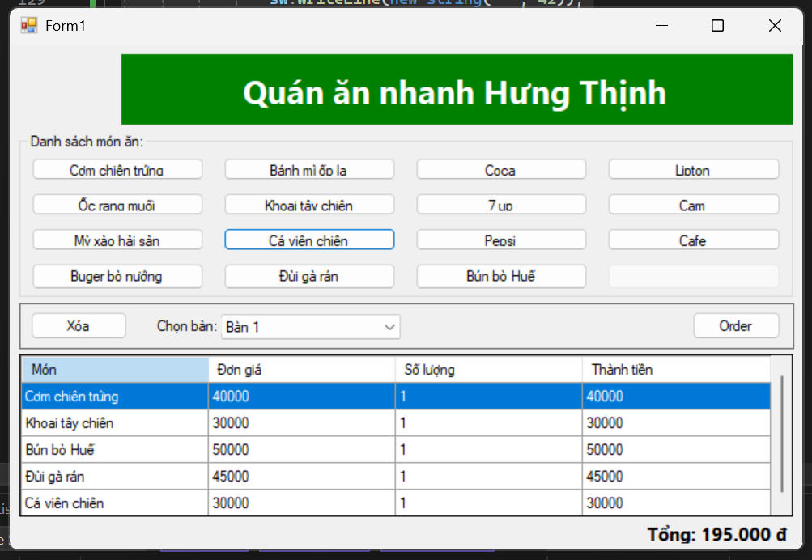

- Thực hành 3:Lab2

Bước 1: Tạo project với tên lab3-2

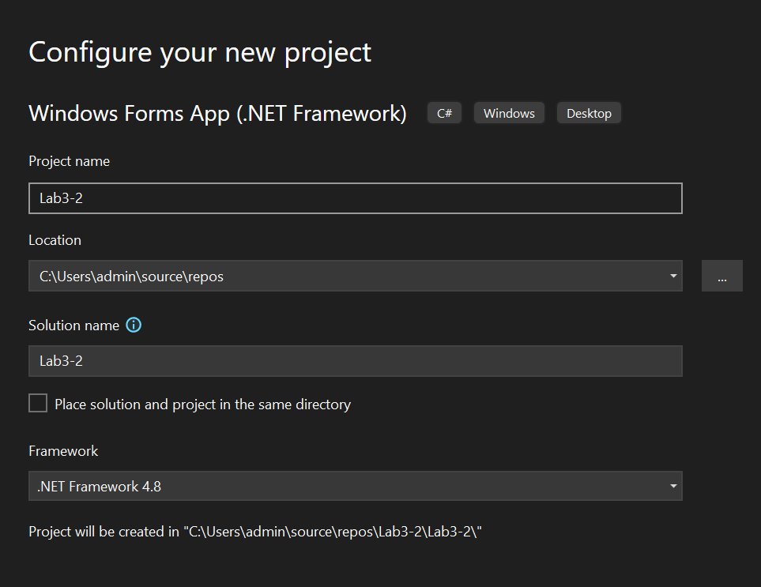

Bước 2 : Thiết kế

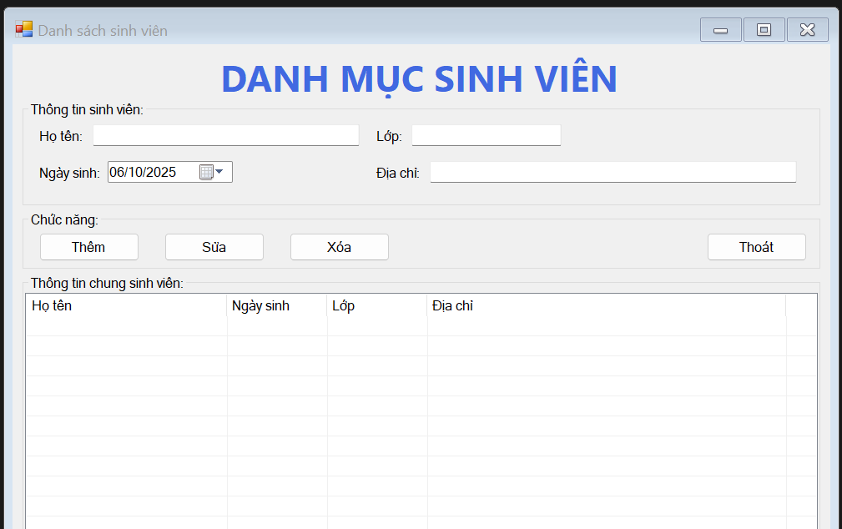

namespace Lab3_2

{

partial class Form1

{

private System.ComponentModel.IContainer components = null;

private System.Windows.Forms.Label lblHeader;

private System.Windows.Forms.GroupBox gbInfo;

private System.Windows.Forms.Label lblHoTen;

private System.Windows.Forms.TextBox txtHoTen;

private System.Windows.Forms.Label lblLop;

private System.Windows.Forms.TextBox txtLop;

private System.Windows.Forms.Label lblNgaySinh;

private System.Windows.Forms.DateTimePicker dtpNgaySinh;

private System.Windows.Forms.Label lblDiaChi;

private System.Windows.Forms.TextBox txtDiaChi;

private System.Windows.Forms.GroupBox gbActions;

private System.Windows.Forms.Button btnThem;

private System.Windows.Forms.Button btnSua;

private System.Windows.Forms.Button btnXoa;

private System.Windows.Forms.Button btnThoat;

private System.Windows.Forms.GroupBox gbList;

private System.Windows.Forms.ListView lvSV;

private System.Windows.Forms.ColumnHeader colHoTen;

private System.Windows.Forms.ColumnHeader colNgaySinh;

private System.Windows.Forms.ColumnHeader colLop;

private System.Windows.Forms.ColumnHeader colDiaChi;

protected override void Dispose(bool disposing)

{

if (disposing && (components != null)) components.Dispose();

base.Dispose(disposing);

}

#region Windows Form Designer generated code

private void InitializeComponent()

{

this.lblHeader = new System.Windows.Forms.Label();

this.gbInfo = new System.Windows.Forms.GroupBox();

this.lblHoTen = new System.Windows.Forms.Label();

this.txtHoTen = new System.Windows.Forms.TextBox();

this.lblLop = new System.Windows.Forms.Label();

this.txtLop = new System.Windows.Forms.TextBox();

this.lblNgaySinh = new System.Windows.Forms.Label();

this.dtpNgaySinh = new System.Windows.Forms.DateTimePicker();

this.lblDiaChi = new System.Windows.Forms.Label();

this.txtDiaChi = new System.Windows.Forms.TextBox();

this.gbActions = new System.Windows.Forms.GroupBox();

this.btnThem = new System.Windows.Forms.Button();

this.btnSua = new System.Windows.Forms.Button();

this.btnXoa = new System.Windows.Forms.Button();

this.btnThoat = new System.Windows.Forms.Button();

this.gbList = new System.Windows.Forms.GroupBox();

this.lvSV = new System.Windows.Forms.ListView();

this.colHoTen = new System.Windows.Forms.ColumnHeader();

this.colNgaySinh = new System.Windows.Forms.ColumnHeader();

this.colLop = new System.Windows.Forms.ColumnHeader();

this.colDiaChi = new System.Windows.Forms.ColumnHeader();

this.gbInfo.SuspendLayout();

this.gbActions.SuspendLayout();

this.gbList.SuspendLayout();

this.SuspendLayout();

// ===== FORM =====

this.AutoScaleDimensions = new System.Drawing.SizeF(9F, 20F);

this.AutoScaleMode = System.Windows.Forms.AutoScaleMode.Font;

this.ClientSize = new System.Drawing.Size(980, 640);

this.MinimumSize = new System.Drawing.Size(900, 600);

this.Name = "Form1";

this.Text = "Danh sách sinh viên";

// ===== HEADER =====

this.lblHeader.Anchor = ((System.Windows.Forms.AnchorStyles)(((System.Windows.Forms.AnchorStyles.Top | System.Windows.Forms.AnchorStyles.Left)

| System.Windows.Forms.AnchorStyles.Right)));

this.lblHeader.Font = new System.Drawing.Font("Segoe UI", 22F, System.Drawing.FontStyle.Bold);

this.lblHeader.ForeColor = System.Drawing.Color.RoyalBlue;

this.lblHeader.Location = new System.Drawing.Point(12, 9);

this.lblHeader.Name = "lblHeader";

this.lblHeader.Size = new System.Drawing.Size(956, 56);

this.lblHeader.TabIndex = 0;

this.lblHeader.Text = "DANH MỤC SINH VIÊN";

this.lblHeader.TextAlign = System.Drawing.ContentAlignment.MiddleCenter;

// ===== GROUPBOX INFO =====

this.gbInfo.Anchor = ((System.Windows.Forms.AnchorStyles)(((System.Windows.Forms.AnchorStyles.Top | System.Windows.Forms.AnchorStyles.Left)

| System.Windows.Forms.AnchorStyles.Right)));

this.gbInfo.Location = new System.Drawing.Point(12, 68);

this.gbInfo.Name = "gbInfo";

this.gbInfo.Size = new System.Drawing.Size(956, 126);

this.gbInfo.TabIndex = 1;

this.gbInfo.TabStop = false;

this.gbInfo.Text = "Thông tin sinh viên:";

// Họ tên

this.lblHoTen.AutoSize = true;

this.lblHoTen.Location = new System.Drawing.Point(16, 32);

this.lblHoTen.Name = "lblHoTen";

this.lblHoTen.Size = new System.Drawing.Size(62, 20);

this.lblHoTen.Text = "Họ tên:";

this.txtHoTen.Location = new System.Drawing.Point(84, 28);

this.txtHoTen.Name = "txtHoTen";

this.txtHoTen.Size = new System.Drawing.Size(320, 26);

// Lớp

this.lblLop.AutoSize = true;

this.lblLop.Location = new System.Drawing.Point(420, 32);

this.lblLop.Name = "lblLop";

this.lblLop.Size = new System.Drawing.Size(40, 20);

this.lblLop.Text = "Lớp:";

this.txtLop.Location = new System.Drawing.Point(466, 28);

this.txtLop.Name = "txtLop";

this.txtLop.Size = new System.Drawing.Size(180, 26);

this.txtLop.TabIndex = 2;

// Ngày sinh

this.lblNgaySinh.AutoSize = true;

this.lblNgaySinh.Location = new System.Drawing.Point(16, 76);

this.lblNgaySinh.Name = "lblNgaySinh";

this.lblNgaySinh.Size = new System.Drawing.Size(80, 20);

this.lblNgaySinh.Text = "Ngày sinh:";

this.dtpNgaySinh.Format = System.Windows.Forms.DateTimePickerFormat.Short;

this.dtpNgaySinh.Location = new System.Drawing.Point(102, 72);

this.dtpNgaySinh.Name = "dtpNgaySinh";

this.dtpNgaySinh.Size = new System.Drawing.Size(150, 26);

// Địa chỉ

this.lblDiaChi.AutoSize = true;

this.lblDiaChi.Location = new System.Drawing.Point(420, 76);

this.lblDiaChi.Name = "lblDiaChi";

this.lblDiaChi.Size = new System.Drawing.Size(62, 20);

this.lblDiaChi.Text = "Địa chỉ:";

this.txtDiaChi.Location = new System.Drawing.Point(488, 72);

this.txtDiaChi.Name = "txtDiaChi";

this.txtDiaChi.Size = new System.Drawing.Size(440, 26);

this.gbInfo.Controls.Add(this.lblHoTen);

this.gbInfo.Controls.Add(this.txtHoTen);

this.gbInfo.Controls.Add(this.lblLop);

this.gbInfo.Controls.Add(this.txtLop);

this.gbInfo.Controls.Add(this.lblNgaySinh);

this.gbInfo.Controls.Add(this.dtpNgaySinh);

this.gbInfo.Controls.Add(this.lblDiaChi);

this.gbInfo.Controls.Add(this.txtDiaChi);

// ===== GROUPBOX ACTIONS =====

this.gbActions.Anchor = ((System.Windows.Forms.AnchorStyles)(((System.Windows.Forms.AnchorStyles.Top | System.Windows.Forms.AnchorStyles.Left)

| System.Windows.Forms.AnchorStyles.Right)));

this.gbActions.Location = new System.Drawing.Point(12, 200);

this.gbActions.Name = "gbActions";

this.gbActions.Size = new System.Drawing.Size(956, 70);

this.gbActions.TabIndex = 2;

this.gbActions.TabStop = false;

this.gbActions.Text = "Chức năng:";

// Thêm

this.btnThem.Location = new System.Drawing.Point(20, 26);

this.btnThem.Name = "btnThem";

this.btnThem.Size = new System.Drawing.Size(120, 34);

this.btnThem.Text = "Thêm";

this.btnThem.UseVisualStyleBackColor = true;

this.btnThem.Click += new System.EventHandler(this.btnThem_Click);

// Sửa

this.btnSua.Location = new System.Drawing.Point(170, 26);

this.btnSua.Name = "btnSua";

this.btnSua.Size = new System.Drawing.Size(120, 34);

this.btnSua.Text = "Sửa";

this.btnSua.Enabled = false;

this.btnSua.UseVisualStyleBackColor = true;

this.btnSua.Click += new System.EventHandler(this.btnSua_Click);

// Xóa

this.btnXoa.Location = new System.Drawing.Point(320, 26);

this.btnXoa.Name = "btnXoa";

this.btnXoa.Size = new System.Drawing.Size(120, 34);

this.btnXoa.Text = "Xóa";

this.btnXoa.Enabled = false;

this.btnXoa.UseVisualStyleBackColor = true;

this.btnXoa.Click += new System.EventHandler(this.btnXoa_Click);

// Thoát

this.btnThoat.Anchor = (System.Windows.Forms.AnchorStyles.Top | System.Windows.Forms.AnchorStyles.Right);

this.btnThoat.Location = new System.Drawing.Point(820, 26);

this.btnThoat.Name = "btnThoat";

this.btnThoat.Size = new System.Drawing.Size(120, 34);

this.btnThoat.Text = "Thoát";

this.btnThoat.UseVisualStyleBackColor = true;

this.btnThoat.Click += new System.EventHandler(this.btnThoat_Click);

this.gbActions.Controls.Add(this.btnThem);

this.gbActions.Controls.Add(this.btnSua);

this.gbActions.Controls.Add(this.btnXoa);

this.gbActions.Controls.Add(this.btnThoat);

// ===== GROUPBOX LIST =====

this.gbList.Anchor = ((System.Windows.Forms.AnchorStyles)((((System.Windows.Forms.AnchorStyles.Top | System.Windows.Forms.AnchorStyles.Bottom)

| System.Windows.Forms.AnchorStyles.Left)

| System.Windows.Forms.AnchorStyles.Right)));

this.gbList.Location = new System.Drawing.Point(12, 276);

this.gbList.Name = "gbList";

this.gbList.Size = new System.Drawing.Size(956, 352);

this.gbList.TabIndex = 3;

this.gbList.TabStop = false;

this.gbList.Text = "Thông tin chung sinh viên:";

// ListView

this.lvSV.Dock = System.Windows.Forms.DockStyle.Fill;

this.lvSV.FullRowSelect = true;

this.lvSV.GridLines = true;

this.lvSV.HideSelection = false;

this.lvSV.MultiSelect = false;

this.lvSV.View = System.Windows.Forms.View.Details;

this.lvSV.SelectedIndexChanged += new System.EventHandler(this.lvSV_SelectedIndexChanged);

this.colHoTen.Text = "Họ tên";

this.colHoTen.Width = 240;

this.colNgaySinh.Text = "Ngày sinh";

this.colNgaySinh.Width = 120;

this.colLop.Text = "Lớp";

this.colLop.Width = 120;

this.colDiaChi.Text = "Địa chỉ";

this.colDiaChi.Width = 430;

this.lvSV.Columns.AddRange(new System.Windows.Forms.ColumnHeader[] {

this.colHoTen, this.colNgaySinh, this.colLop, this.colDiaChi

});

this.gbList.Controls.Add(this.lvSV);

// ===== Add Controls to Form =====

this.Controls.Add(this.lblHeader);

this.Controls.Add(this.gbInfo);

this.Controls.Add(this.gbActions);

this.Controls.Add(this.gbList);

this.gbInfo.ResumeLayout(false);

this.gbInfo.PerformLayout();

this.gbActions.ResumeLayout(false);

this.gbList.ResumeLayout(false);

this.ResumeLayout(false);

}

#endregion

}

}

Bước 3: Form.cs xử lý dữ liệu

using System;

using System.Collections.Generic;

using System.ComponentModel;

using System.Data;

using System.Drawing;

using System.Linq;

using System.Text;

using System.Threading.Tasks;

using System.Windows.Forms;

namespace Lab3_2

{

public partial class Form1 : Form

{

public Form1()

{

InitializeComponent();

// Phím tắt: Enter = Thêm, Esc = Thoát

this.AcceptButton = btnThem;

this.CancelButton = btnThoat;

}

// ====== Helpers ======

private void ClearInputs()

{

txtHoTen.Clear();

txtLop.Clear();

txtDiaChi.Clear();

dtpNgaySinh.Value = DateTime.Today;

txtHoTen.Focus();

}

private void FillInputsFromSelected()

{

if (lvSV.SelectedItems.Count == 0) return;

var it = lvSV.SelectedItems[0];

txtHoTen.Text = it.SubItems[0].Text;

DateTime d;

if (DateTime.TryParse(it.SubItems[1].Text, out d))

dtpNgaySinh.Value = d;

txtLop.Text = it.SubItems[2].Text;

txtDiaChi.Text = it.SubItems[3].Text;

}

private void SetActionButtonsEnabled()

{

bool hasSel = lvSV.SelectedItems.Count > 0;

btnSua.Enabled = hasSel;

btnXoa.Enabled = hasSel;

}

// ====== Events ======

private void btnThem_Click(object sender, EventArgs e)

{

if (string.IsNullOrWhiteSpace(txtHoTen.Text))

{

MessageBox.Show("Họ tên không được rỗng!", "Lỗi nhập liệu",

MessageBoxButtons.OK, MessageBoxIcon.Warning);

txtHoTen.Focus();

return;

}

var item = new ListViewItem(txtHoTen.Text.Trim());

item.SubItems.Add(dtpNgaySinh.Value.ToString("dd/MM/yyyy"));

item.SubItems.Add(txtLop.Text.Trim());

item.SubItems.Add(txtDiaChi.Text.Trim());

lvSV.Items.Add(item);

ClearInputs();

SetActionButtonsEnabled();

}

private void btnSua_Click(object sender, EventArgs e)

{

if (lvSV.SelectedItems.Count == 0)

{

MessageBox.Show("Hãy chọn 1 dòng cần sửa!", "Thông báo");

return;

}

if (string.IsNullOrWhiteSpace(txtHoTen.Text))

{

MessageBox.Show("Họ tên không được rỗng!", "Lỗi nhập liệu");

txtHoTen.Focus();

return;

}

var it = lvSV.SelectedItems[0];

it.SubItems[0].Text = txtHoTen.Text.Trim();

it.SubItems[1].Text = dtpNgaySinh.Value.ToString("dd/MM/yyyy");

it.SubItems[2].Text = txtLop.Text.Trim();

it.SubItems[3].Text = txtDiaChi.Text.Trim();

}

private void btnXoa_Click(object sender, EventArgs e)

{

if (lvSV.SelectedItems.Count == 0)

{

MessageBox.Show("Hãy chọn 1 dòng cần xóa!", "Thông báo");

return;

}

lvSV.Items.Remove(lvSV.SelectedItems[0]);

SetActionButtonsEnabled();

ClearInputs();

}

private void btnThoat_Click(object sender, EventArgs e)

{

this.Close();

}

private void lvSV_SelectedIndexChanged(object sender, EventArgs e)

{

SetActionButtonsEnabled();

if (lvSV.SelectedItems.Count > 0)

FillInputsFromSelected();

}

}

}

Bước 4: test

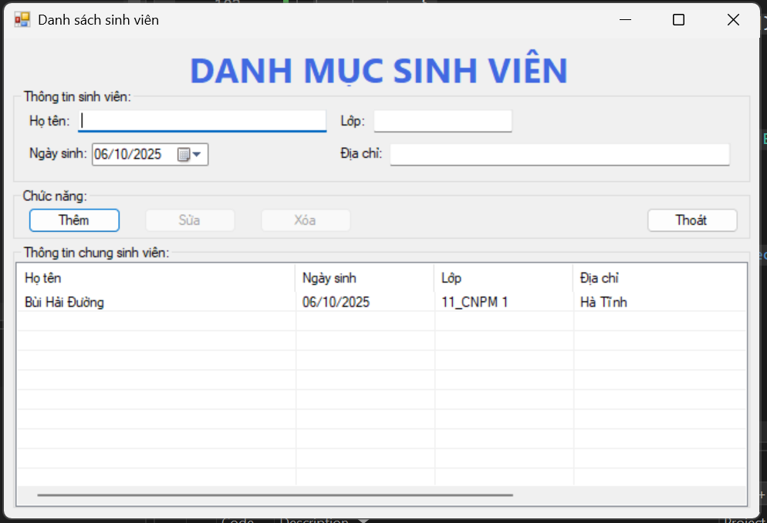

+Lab 4:

Thực hành 1: Chuỗi kết nối

Bước 1 tạo project tên: Lab4

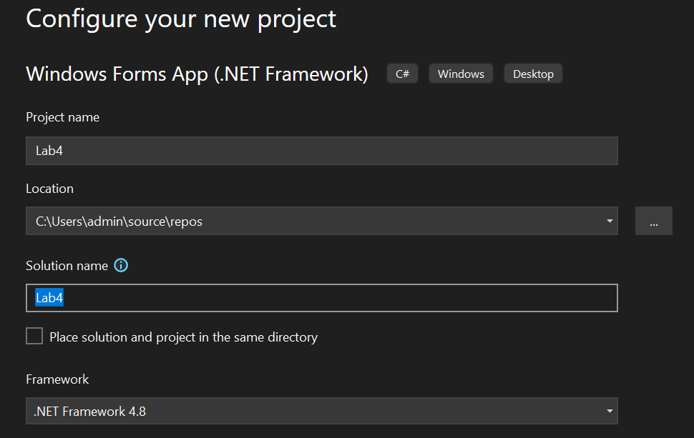

Bước 2 :

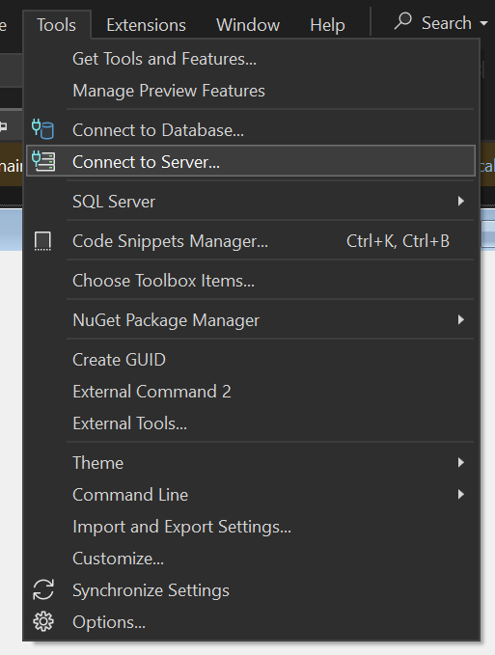

Kết nối database với tên sql là LAPTOP-1OLPGQ5K\SUGAR; Database name: StudentDb

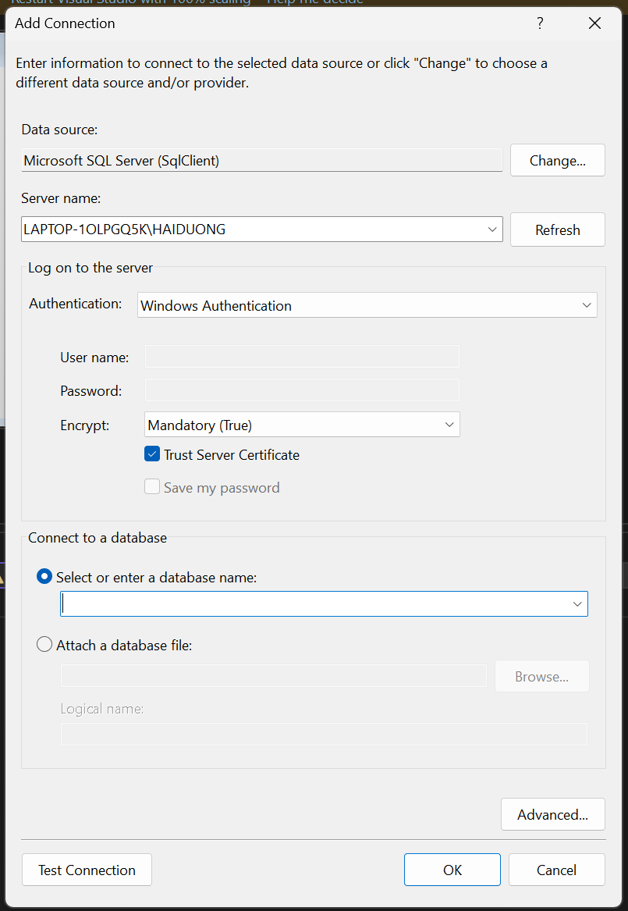

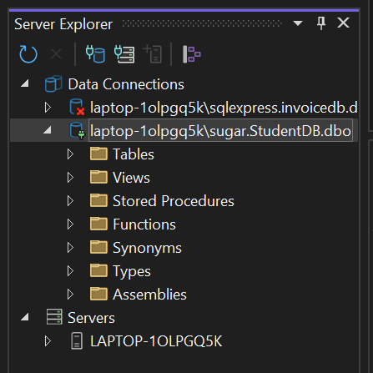

Bước 3:

Tạo giao diện kết nối và ngắt kết nối

-Form.cs

using System;

using System.Data;

using System.Data.SqlClient;

using System.Windows.Forms;

namespace Lab4

{

public partial class Form1 : Form

{

private string strCon = @"Data Source=LAPTOP-1OLPGQ5K\SUGAR;Initial Catalog=QLSV;Integrated Security=True";

private SqlConnection sqlCon = null;

public Form1()

{

InitializeComponent();

}

private void btnMoKetNoi_Click(object sender, EventArgs e)

{

try

{

if (sqlCon == null)

sqlCon = new SqlConnection(strCon);

if (sqlCon.State == ConnectionState.Closed)

{

sqlCon.Open();

lblStatus.Text = "✅ Kết nối thành công!";

lblStatus.ForeColor = System.Drawing.Color.Green;

MessageBox.Show("Kết nối thành công!");

}

}

catch (Exception ex)

{

MessageBox.Show("❌ Lỗi: " + ex.Message);

}

}

private void btnDongKetNoi_Click(object sender, EventArgs e)

{

if (sqlCon != null && sqlCon.State == ConnectionState.Open)

{

sqlCon.Close();

lblStatus.Text = "🔴 Đã đóng kết nối";

lblStatus.ForeColor = System.Drawing.Color.Red;

MessageBox.Show("Đã đóng kết nối!");

}

}

}

}

Form.Design.cs

namespace Lab4

{

partial class Form1

{

/// <summary>

/// Required designer variable.

/// </summary>

private System.ComponentModel.IContainer components = null;

/// <summary>

/// Clean up any resources being used.

/// </summary>

/// <param name="disposing">true if managed resources should be disposed; otherwise, false.</param>

protected override void Dispose(bool disposing)

{

if (disposing && (components != null))

{

components.Dispose();

}

base.Dispose(disposing);

}

#region Windows Form Designer generated code

private void InitializeComponent()

{

this.lblStatus = new System.Windows.Forms.Label();

this.btnMoKetNoi = new System.Windows.Forms.Button();

this.btnDongKetNoi = new System.Windows.Forms.Button();

this.SuspendLayout();

//

// lblStatus

//

this.lblStatus.AutoSize = true;

this.lblStatus.Font = new System.Drawing.Font("Segoe UI", 12F, System.Drawing.FontStyle.Bold);

this.lblStatus.ForeColor = System.Drawing.Color.Red;

this.lblStatus.Location = new System.Drawing.Point(40, 30);

this.lblStatus.Name = "lblStatus";

this.lblStatus.Size = new System.Drawing.Size(176, 28);

this.lblStatus.TabIndex = 0;

this.lblStatus.Text = "Chưa kết nối SQL";

//

// btnMoKetNoi

//

this.btnMoKetNoi.Font = new System.Drawing.Font("Segoe UI", 10F);

this.btnMoKetNoi.Location = new System.Drawing.Point(45, 90);

this.btnMoKetNoi.Name = "btnMoKetNoi";

this.btnMoKetNoi.Size = new System.Drawing.Size(150, 40);

this.btnMoKetNoi.TabIndex = 1;

this.btnMoKetNoi.Text = "Mở kết nối";

this.btnMoKetNoi.UseVisualStyleBackColor = true;

this.btnMoKetNoi.Click += new System.EventHandler(this.btnMoKetNoi_Click);

//

// btnDongKetNoi

//

this.btnDongKetNoi.Font = new System.Drawing.Font("Segoe UI", 10F);

this.btnDongKetNoi.Location = new System.Drawing.Point(210, 90);

this.btnDongKetNoi.Name = "btnDongKetNoi";

this.btnDongKetNoi.Size = new System.Drawing.Size(150, 40);

this.btnDongKetNoi.TabIndex = 2;

this.btnDongKetNoi.Text = "Đóng kết nối";

this.btnDongKetNoi.UseVisualStyleBackColor = true;

this.btnDongKetNoi.Click += new System.EventHandler(this.btnDongKetNoi_Click);

//

// Form1

//

this.AutoScaleDimensions = new System.Drawing.SizeF(8F, 20F);

this.AutoScaleMode = System.Windows.Forms.AutoScaleMode.Font;

this.ClientSize = new System.Drawing.Size(420, 180);

this.Controls.Add(this.btnDongKetNoi);

this.Controls.Add(this.btnMoKetNoi);

this.Controls.Add(this.lblStatus);

this.Name = "Form1";

this.StartPosition = System.Windows.Forms.FormStartPosition.CenterScreen;

this.Text = "Thực hành 1 - Kết nối CSDL";

this.ResumeLayout(false);

this.PerformLayout();

}

#endregion

private System.Windows.Forms.Label lblStatus;

private System.Windows.Forms.Button btnMoKetNoi;

private System.Windows.Forms.Button btnDongKetNoi;

}

}

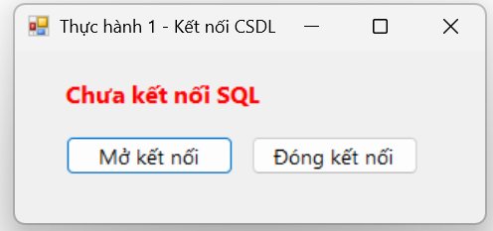

Lab 4 - Thực hành 2

- Form1.Designer.cs (thiết kế)

namespace Lab4

{

partial class Form1

{

private System.ComponentModel.IContainer components = null;

private System.Windows.Forms.Label lblTitle;

private System.Windows.Forms.TextBox txtMaSV;

private System.Windows.Forms.Button btnXemThongTin;

private System.Windows.Forms.Button btnXemTatCa;

private System.Windows.Forms.ListView lvSinhVien;

private System.Windows.Forms.ColumnHeader colMaSV;

private System.Windows.Forms.ColumnHeader colTenSV;

private System.Windows.Forms.ColumnHeader colGioiTinh;

private System.Windows.Forms.ColumnHeader colNgaySinh;

private System.Windows.Forms.ColumnHeader colQueQuan;

private System.Windows.Forms.ColumnHeader colMaLop;

protected override void Dispose(bool disposing)

{

if (disposing && (components != null)) components.Dispose();

base.Dispose(disposing);

}

private void InitializeComponent()

{

this.lblTitle = new System.Windows.Forms.Label();

this.txtMaSV = new System.Windows.Forms.TextBox();

this.btnXemThongTin = new System.Windows.Forms.Button();

this.btnXemTatCa = new System.Windows.Forms.Button();

this.lvSinhVien = new System.Windows.Forms.ListView();

this.colMaSV = new System.Windows.Forms.ColumnHeader();

this.colTenSV = new System.Windows.Forms.ColumnHeader();

this.colGioiTinh = new System.Windows.Forms.ColumnHeader();

this.colNgaySinh = new System.Windows.Forms.ColumnHeader();

this.colQueQuan = new System.Windows.Forms.ColumnHeader();

this.colMaLop = new System.Windows.Forms.ColumnHeader();

this.SuspendLayout();

//

// lblTitle

//

this.lblTitle.Font = new System.Drawing.Font("Segoe UI", 16F, System.Drawing.FontStyle.Bold);

this.lblTitle.ForeColor = System.Drawing.Color.RoyalBlue;

this.lblTitle.Location = new System.Drawing.Point(12, 9);

this.lblTitle.Name = "lblTitle";

this.lblTitle.Size = new System.Drawing.Size(776, 40);

this.lblTitle.Text = "DANH SÁCH SINH VIÊN";

this.lblTitle.TextAlign = System.Drawing.ContentAlignment.MiddleCenter;

//

// txtMaSV

//

this.txtMaSV.Location = new System.Drawing.Point(30, 65);

this.txtMaSV.Name = "txtMaSV";

this.txtMaSV.PlaceholderText = "Nhập mã sinh viên (ví dụ 0200000004)";

this.txtMaSV.Size = new System.Drawing.Size(350, 27);

//

// btnXemThongTin

//

this.btnXemThongTin.Location = new System.Drawing.Point(400, 60);

this.btnXemThongTin.Name = "btnXemThongTin";

this.btnXemThongTin.Size = new System.Drawing.Size(160, 35);

this.btnXemThongTin.Text = "Xem thông tin";

this.btnXemThongTin.UseVisualStyleBackColor = true;

this.btnXemThongTin.Click += new System.EventHandler(this.btnXemThongTin_Click);

//

// btnXemTatCa

//

this.btnXemTatCa.Location = new System.Drawing.Point(580, 60);

this.btnXemTatCa.Name = "btnXemTatCa";

this.btnXemTatCa.Size = new System.Drawing.Size(160, 35);

this.btnXemTatCa.Text = "Xem tất cả";

this.btnXemTatCa.UseVisualStyleBackColor = true;

this.btnXemTatCa.Click += new System.EventHandler(this.btnXemTatCa_Click);

//

// lvSinhVien

//

this.lvSinhVien.Anchor = ((System.Windows.Forms.AnchorStyles)((((System.Windows.Forms.AnchorStyles.Top | System.Windows.Forms.AnchorStyles.Bottom)

| System.Windows.Forms.AnchorStyles.Left)

| System.Windows.Forms.AnchorStyles.Right)));

this.lvSinhVien.Columns.AddRange(new System.Windows.Forms.ColumnHeader[] {

this.colMaSV, this.colTenSV, this.colGioiTinh, this.colNgaySinh, this.colQueQuan, this.colMaLop});

this.lvSinhVien.FullRowSelect = true;

this.lvSinhVien.GridLines = true;

this.lvSinhVien.HideSelection = false;

this.lvSinhVien.Location = new System.Drawing.Point(12, 110);

this.lvSinhVien.Name = "lvSinhVien";

this.lvSinhVien.Size = new System.Drawing.Size(776, 328);

this.lvSinhVien.View = System.Windows.Forms.View.Details;

//

// Các cột

//

this.colMaSV.Text = "Mã SV";

this.colMaSV.Width = 100;

this.colTenSV.Text = "Họ tên";

this.colTenSV.Width = 180;

this.colGioiTinh.Text = "Giới tính";

this.colGioiTinh.Width = 80;

this.colNgaySinh.Text = "Ngày sinh";

this.colNgaySinh.Width = 100;

this.colQueQuan.Text = "Quê quán";

this.colQueQuan.Width = 150;

this.colMaLop.Text = "Mã lớp";

this.colMaLop.Width = 100;

//

// Form1

//

this.AutoScaleDimensions = new System.Drawing.SizeF(8F, 20F);

this.ClientSize = new System.Drawing.Size(800, 450);

this.Controls.Add(this.lvSinhVien);

this.Controls.Add(this.btnXemTatCa);

this.Controls.Add(this.btnXemThongTin);

this.Controls.Add(this.txtMaSV);

this.Controls.Add(this.lblTitle);

this.Name = "Form1";

this.StartPosition = System.Windows.Forms.FormStartPosition.CenterScreen;

this.Text = "Thực hành 2 - Truy vấn dữ liệu";

this.ResumeLayout(false);

this.PerformLayout();

}

}

}

Form1.cs (code xử lý truy vấn)

using System;

using System.Data;

using System.Data.SqlClient;

using System.Windows.Forms;

namespace Lab4

{

public partial class Form1 : Form

{

// 🔹 Chuỗi kết nối CSDL (sửa tên máy và CSDL cho đúng)

private string strCon = @"Data Source=LAPTOP-1OLPGQ5K\SUGAR;Initial Catalog=StudentDB;Integrated Security=True";

private SqlConnection sqlCon = null;

public Form1()

{

InitializeComponent();

}

// ======= Xem thông tin 1 sinh viên =======

private void btnXemThongTin_Click(object sender, EventArgs e)

{

if (string.IsNullOrWhiteSpace(txtMaSV.Text))

{

MessageBox.Show("Hãy nhập mã sinh viên!");

return;

}

try

{

if (sqlCon == null)

sqlCon = new SqlConnection(strCon);

if (sqlCon.State == ConnectionState.Closed)

sqlCon.Open();

string maSV = txtMaSV.Text.Trim();

SqlCommand cmd = new SqlCommand("SELECT * FROM SinhVien WHERE MaSV=@maSV", sqlCon);

cmd.Parameters.Add(new SqlParameter("@maSV", maSV));

SqlDataReader reader = cmd.ExecuteReader();

lvSinhVien.Items.Clear();

if (reader.Read())

{

ListViewItem lvi = new ListViewItem(reader.GetString(0)); // MaSV

lvi.SubItems.Add(reader.GetString(1)); // TenSV

lvi.SubItems.Add(reader.GetString(2)); // GioiTinh

lvi.SubItems.Add(reader.GetDateTime(3).ToString("dd/MM/yyyy")); // NgaySinh

lvi.SubItems.Add(reader.GetString(4)); // QueQuan

lvi.SubItems.Add(reader.GetString(5)); // MaLop

lvSinhVien.Items.Add(lvi);

}

else

{

MessageBox.Show("Không tìm thấy sinh viên có mã: " + maSV);

}

reader.Close();

}

catch (Exception ex)

{

MessageBox.Show("Lỗi truy vấn: " + ex.Message);

}

}

// ======= Xem toàn bộ danh sách =======

private void btnXemTatCa_Click(object sender, EventArgs e)

{

try

{

if (sqlCon == null)

sqlCon = new SqlConnection(strCon);

if (sqlCon.State == ConnectionState.Closed)

sqlCon.Open();

SqlCommand cmd = new SqlCommand("SELECT * FROM SinhVien", sqlCon);

SqlDataReader reader = cmd.ExecuteReader();

lvSinhVien.Items.Clear();

while (reader.Read())

{

ListViewItem lvi = new ListViewItem(reader.GetString(0)); // MaSV

lvi.SubItems.Add(reader.GetString(1)); // TenSV

lvi.SubItems.Add(reader.GetString(2)); // GioiTinh

lvi.SubItems.Add(reader.GetDateTime(3).ToString("dd/MM/yyyy")); // NgaySinh

lvi.SubItems.Add(reader.GetString(4)); // QueQuan

lvi.SubItems.Add(reader.GetString(5)); // MaLop

lvSinhVien.Items.Add(lvi);

}

reader.Close();

}

catch (Exception ex)

{

MessageBox.Show("Lỗi: " + ex.Message);

}

}

}

}

Bước 2: xem và truy vấn dữ liệu

